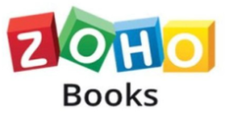

|  |  |
| --- | --- |
| COURSE NAME: | FINANCE & ACCOUNTING WITH ZOHO BOOKS |
| PROJECT TITLE: | PREPARATION AND MAINTENANCE OF ZOHO BOOKS FOR HEALTHHUB MEDICAL CLINIC |
| PROJECT SUBMITTED TO: | SMART INTERNZ |
| YEAR: | 2023-2024 |
| DEPARTMENT: | COMMERCE |
| SEMESTER: | V |
| TEAM ID: | NM2023TMID10364 |
| MEMBERS OF THE GROUP: | |  |  | | --- | --- | | Register No | Student Name | | 1321151012 | V.HARINI (TEAM LEADER) | | 1321151010 | V.GAYATHIRILAKSHMI | | 1321151011 | A.HARINI | | 1321151013 | P.KARTHIGAI SELVI | |
| GUIDED BY: | Mrs.M.PRIYANKA, M.Com(CA)., M.Phil., Assistant Professor  Ms.S.GOWSALYA M.COM.,M.PHIL Assistant Professor |
| SPOC NAME: | Ms. K. Elizabeth, M.Sc., M.Phil., B.Ed., Assistant Professor |

### ****INDEX****

|  |  |
| --- | --- |
| **PARTICULARS** | **PAGE NO** |
| **INTRODUCTION** | **3** |
| **PROBLEM DEFINITION &DESIGN THINKING** | **4** |
| **RESULT** | **6** |
| **ADVANTAGES & DISADVANTAGES** | **8** |
| **APPLICATION** | **8** |
| **CONCLUSION** | **8** |
| **FUTURE SCOPE** | **9** |

**PREPARATION AND MAINTENANCE OF ZOHO BOOKS FOR HEALTHHUB MEDICAL CLINIC**

## INTRODUCTION

Zoho Books is an accounting solution that is designed to help small businesses manage their finances. This solution includes dashboards and a wide variety of reports. Business users can automate tasks and set up custom workflows.

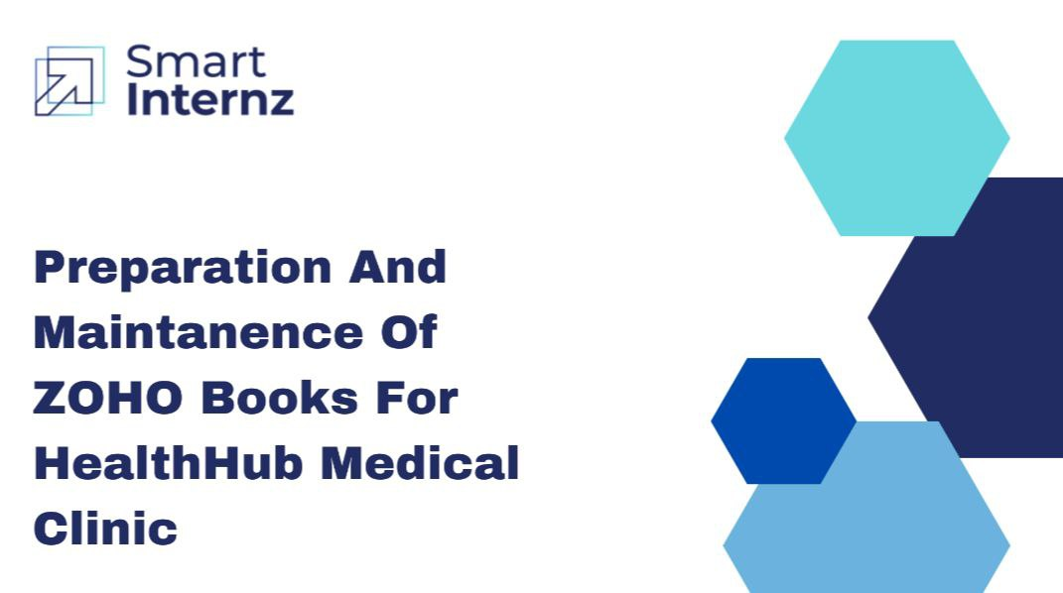

## 1.1 OVERVIEW:

### Zoho books:

Zoho Books is cloud-based smart accounting software which takes care of all our accounting needs. To fully understand how Zoho Books works, go through modules below in the given order.

### Project Description:

HealthHub Medical Clinic, a healthcare facility, relies on Zoho Books to manage patient billing and invoicing.these medical clinics are used in both urban and rural areas. A personal digital health hub can specifically collate and interpret useful health information, facilitating the integration of data from different health services and other personalized digital data sources.

This personalized hub is potentially a powerful tool, empowering patients to take greater control of their health goals.The major limiting factor, however, is that current applications are not connected to mainstream health services and are not linked to the professional networks of family practitioners or specialists.

In contrast, processes that are specifically designed around the individual can link patients into a more extensive network of specialists, general practitioners and community carers. This holistic approach is important for the development of a strongly integrated team approach that is more responsive to the needs of patients and communities.

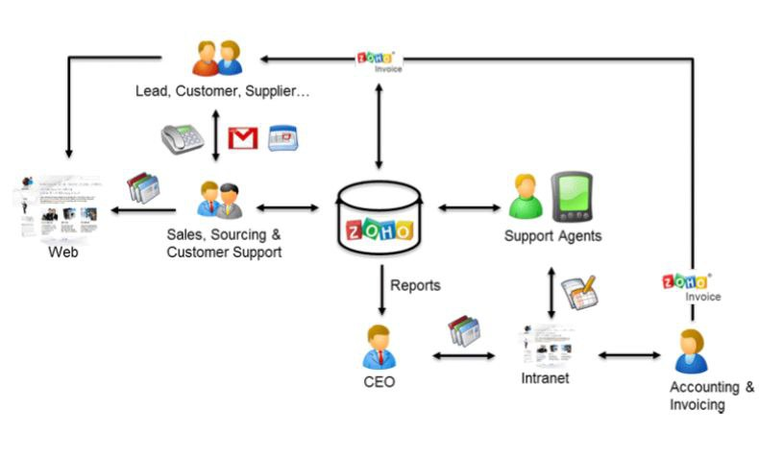

## PURPOSE:

They can track medical service fees, manage insurance payments, and generate statements for patients. Zoho Books helps them maintain financial transparency and ensures efficient billing processes.  the Digital Health Hub brings together competencies from science and business. Technologies and networks with internationally leading research institutions and medical technology companies are thus taken to the next level and supported locally.

The purpose of zoho books in Health hub medical clinic they connect people to learn through the online platform and get more benefit about the topics and also learn more things, gets lots of information. An online platform is a digital service that uses the Internet to facilitate interactions between two or more separate but interdependent users.

## 2. PROBLEM DEFINITION & DESIGN THINKING

### 2.1 EMPATHY MAP

In, an empathy map is a simple visual that captures knowledge about the behaviors, attitudes, needs, strengths, struggles, emotional states, and other key attributes of a particular student or group of students

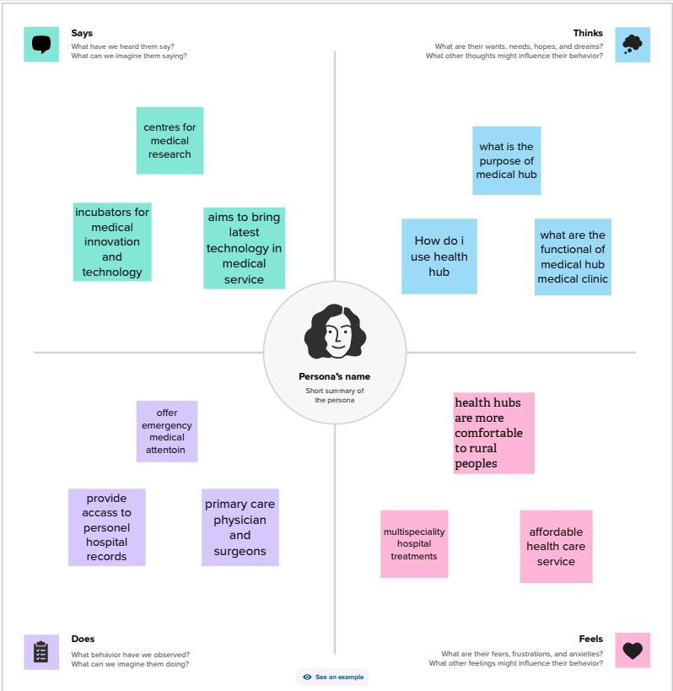

**2.2 IDEATION & BRAINSTROMING MAP**

Brainstorming is a large- or small-group discussion that encourages students to generate a wide range of perspectives or potential next steps or solutions regarding a specific topic.

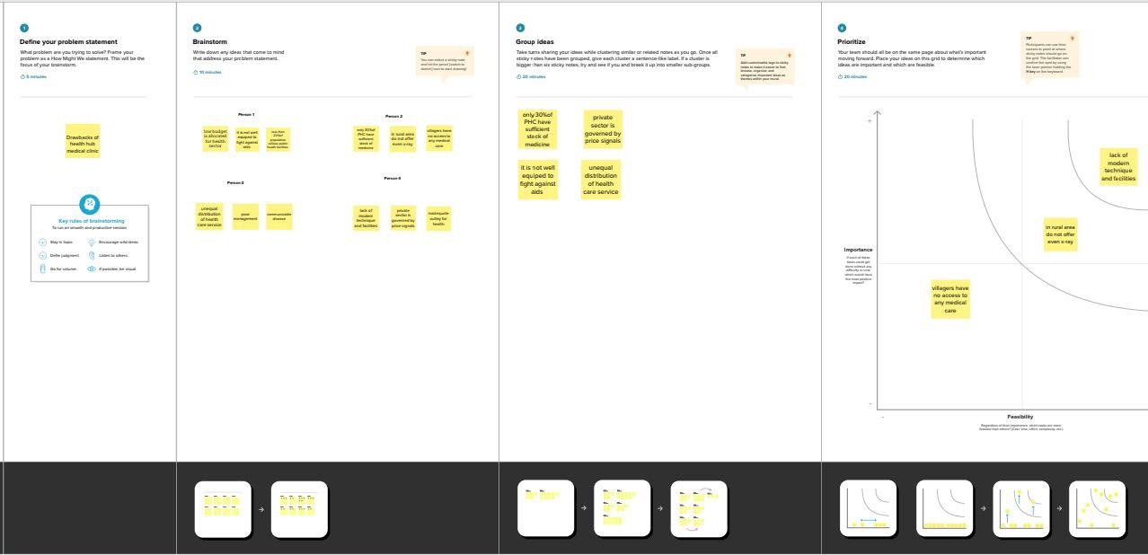

3. RESULTS:

### ****Final output of the project****

### PROFIT & LOSS

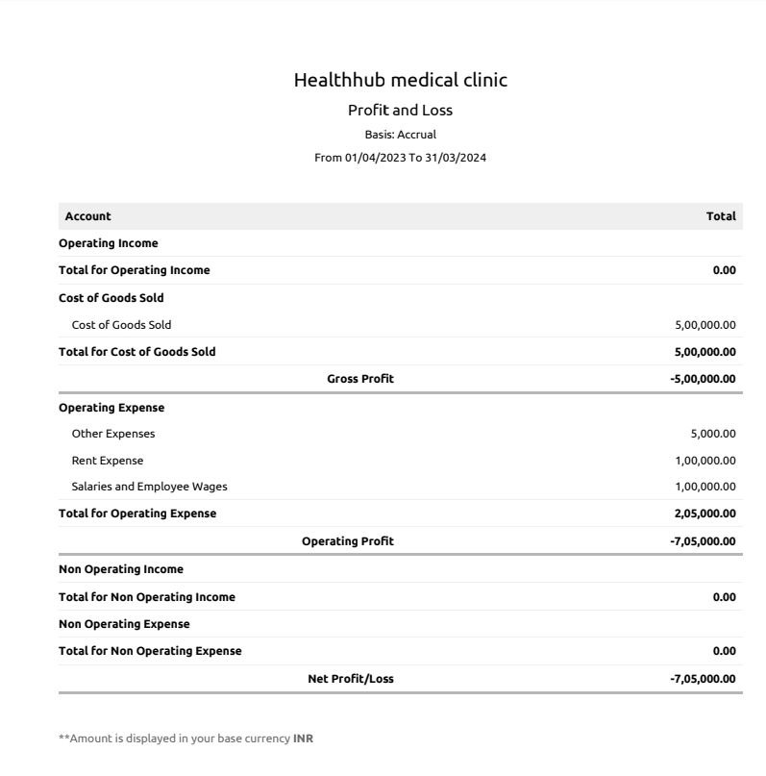

## 

### ****BALANCE SHEET****

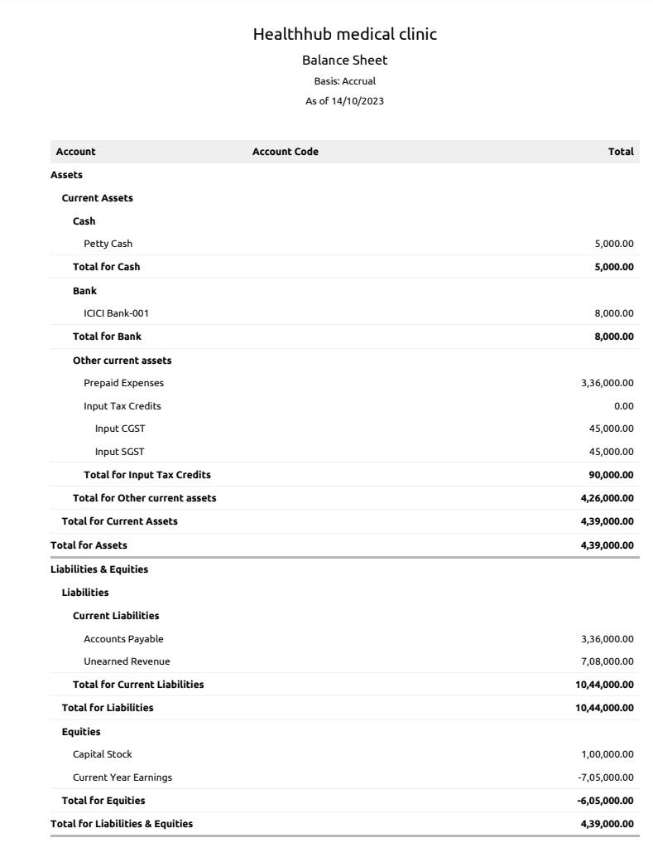

4. Advantages and disadvantages

### ****ADVANTAGES :****

* **Invoicing and billing**
* **Expense tracking**
* **Minimize data loss**
* **Report generation**
* **Inventory management**

### ****DISADVANTAGES****

* **Difficult To Modify Invoice**
* **Maximum of 10 Users**
* **Time Tracking must Be Tied To Project**
* **Limited Bank Syncing**
* **Difficult To Modify bills**

5. APPLICATION

**The Zoho Books Are Applied In Our Business To Record The Sales And Purchase To Generate Invoice And Bill And Manages The Customer Payment And Vendor Payment. It Also Maintain The Expense And Other Transaction Related To The Business And We Can Also Maintain The Cash Book And Bank Accounts In This Cloud Based Accounting Software. It Also Gives All The Financial Report About The Profit And Loss A/C, Balance Sheet, GST Report, Account Receivable Ar Aging Details, Account Payable Ar Aging Details And Etc. This All The Details Can Help To Make Decision Making For Future Business Purposes.**

6. CONCLUSION:

**The Zoho Books Are Usefull To Maintain, Record, Summarize And Analysis Accounting Entries Made In This Cloud Based Software. We Need Any Manual Records To Maintain The Accounts. That The Transaction Are Recorded While The Entering In This Software. Then We Can Add The Journal And Then We Can Get The Profit And Loss A/C, Balance Sheet, Gst Report And Etc. We Don't Need One Software To Enter Bill And Software To Maintain Accounts. We Can Prepare The Bill And Maintain Accounts In One Software.**

7. FUTURE SCOPE

* **It Is Helpful To Recover In Health Issues**
* **In Future It Cover All Areas**
* **Seperate Centers Will Be Opened In Urban And Semi Urban Areas...**
* **It Is Best Software To Maintain Accounts**
* **Reduce The Time To Maintain Accounts**

### 